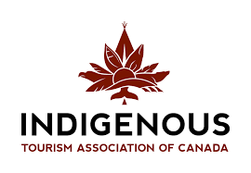
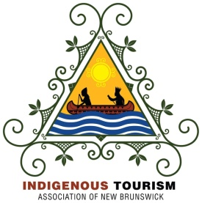
www.atlanticindigenoustourismsummit.com
2019 Atlantic Indigenous Tourism Conference
Moncton, N.B. - Crowne Plaza Hotel – May 7-9, 2019

Sponsorship Opportunities
Full Summit Sponsor: $25,000.00 Keynote introductions, Promotional Table,
Online Web Promotion and full summit
recognition-all media plus ten (10) full
Conference Registrations & Banquet Dinner
Banquet Dinner Sponsor: $10,000.00 Keynote Introductions, Promotional Table,
Workshop introduction opportunities, Event
Recognition plus five (5) full Conference
Registrations & Banquet Dinner
Marketplace Sponsor: $5,000.00 Keynote welcome, Sponsor banners and full
event coverage plus three (3) full Conference
Registrations & Banquet Dinner

Summit Champions: $2,500.00 Promotional Information Table (May 7-8)
plus two (2) full Conference Registration,

Including 2 seats to Banquet Dinner

Summit Partners: $1,000.00 Listed on Conference Program and online
sponsor including one (1) full Conference Registration and Banquet Dinner

**********************************************************************************************************************
Please contact Robert Bernard: (902) 302-3300 (Cellular)
ITAC Atlantic Coordinator www.atlanticindigenoustourismsummit.com
Robert@indigenoustourism.ca

Sponsors can pay by Government / Certified Cheque or Money Order:
Payable to: Indigenous Tourism Association of New Brunswick
C/O: Patricia Dunnett, Chairperson
2156 Micmac Road, Red Bank
New Brunswick E9E 2P2
**********************************************************************************************************************

